**Procedure:-**

Step 1: Click on Compute lab.

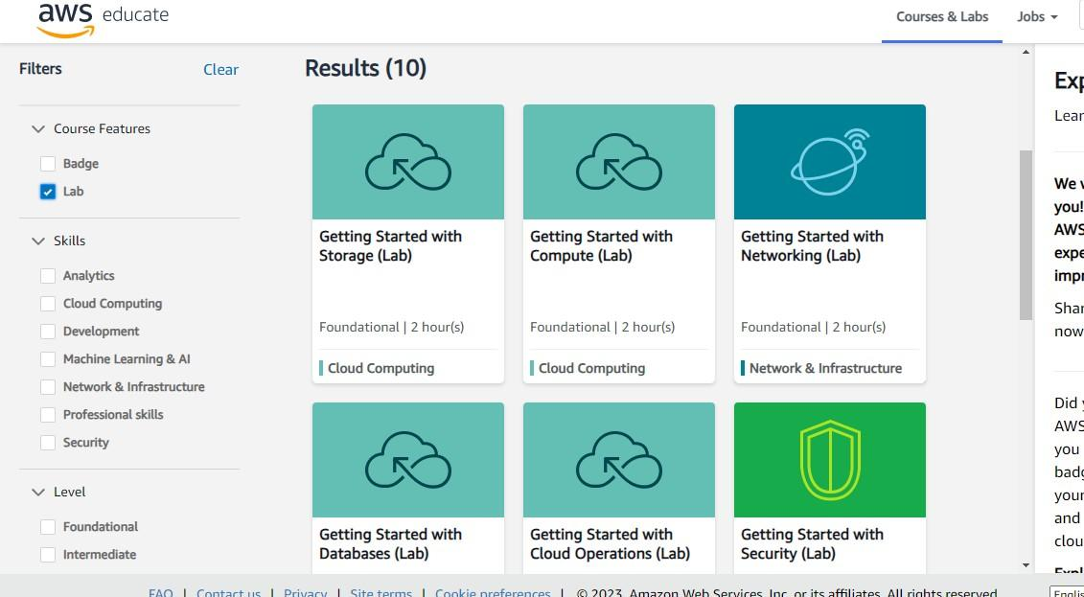

Step 2: Click on next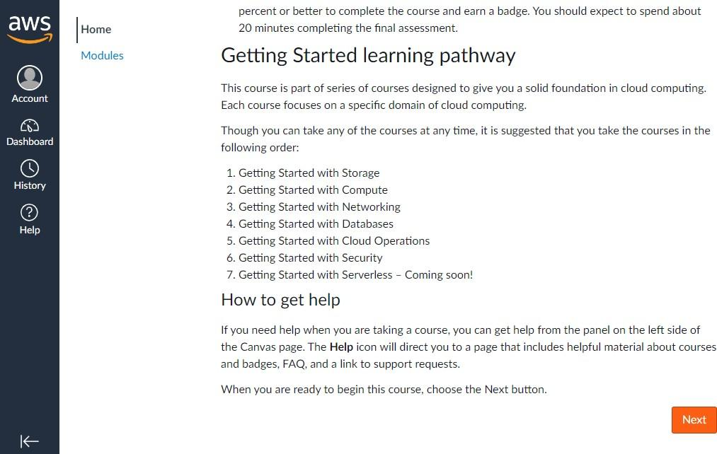

Step 3: Click on start Lab.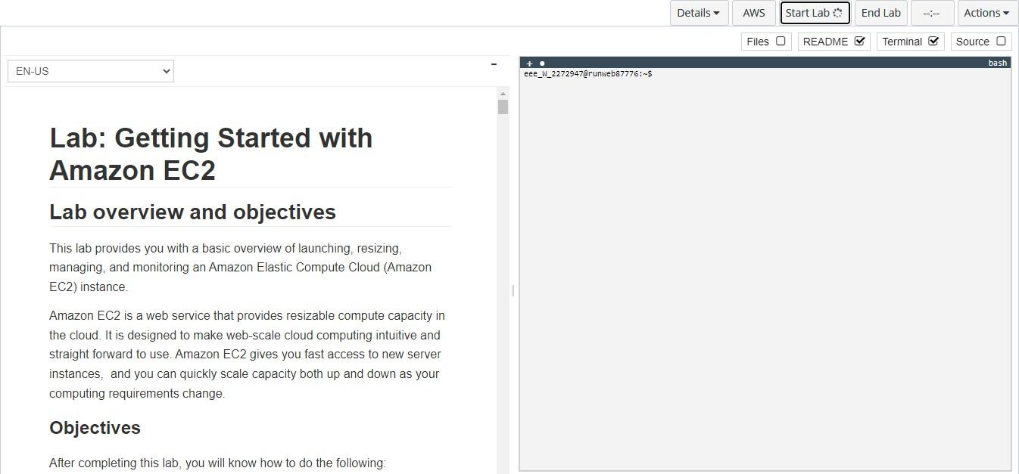

Step 4: Click on services.

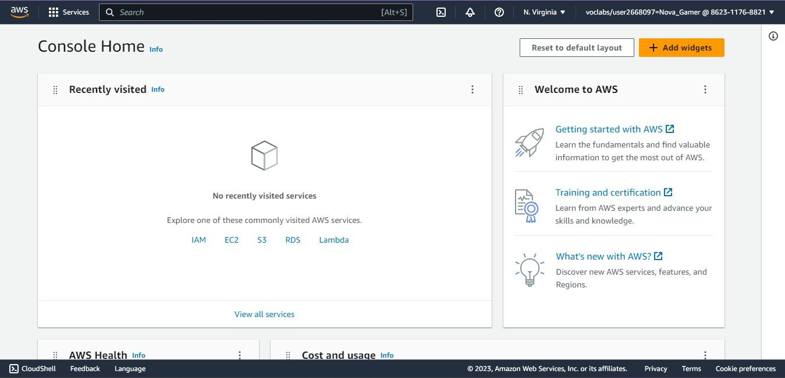

Step 5: Click on EC2 instances.

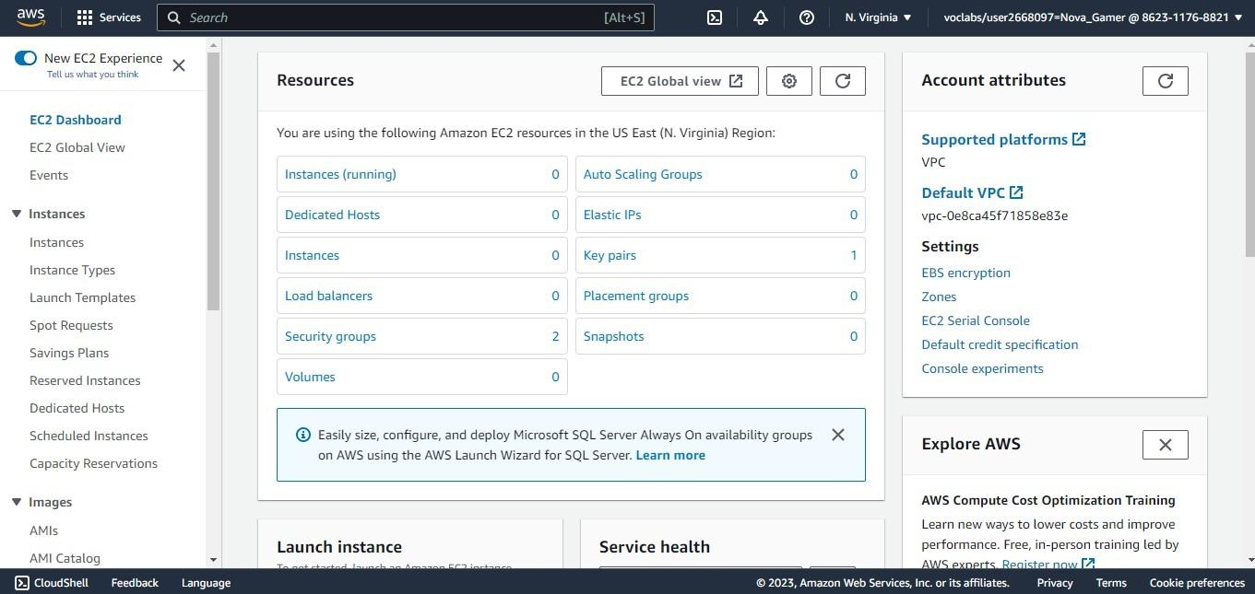

Step 6: Enter your instances name, select your OS and launch instance.

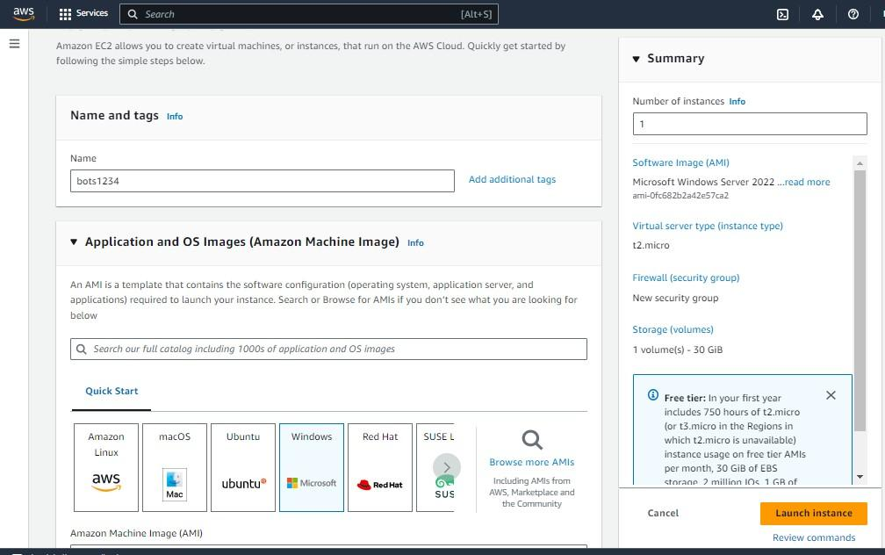

Step 7: Instance created successfully.

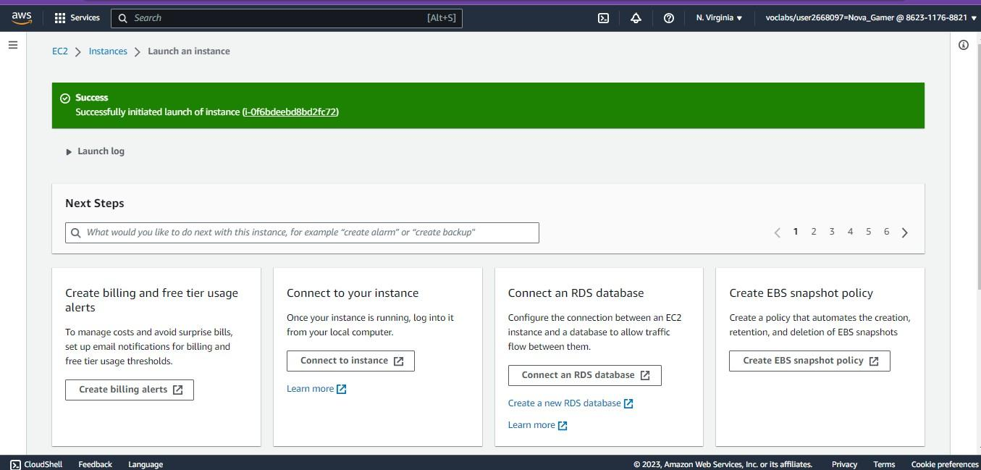

Step 8: Connect to your Instance through RDP Client.

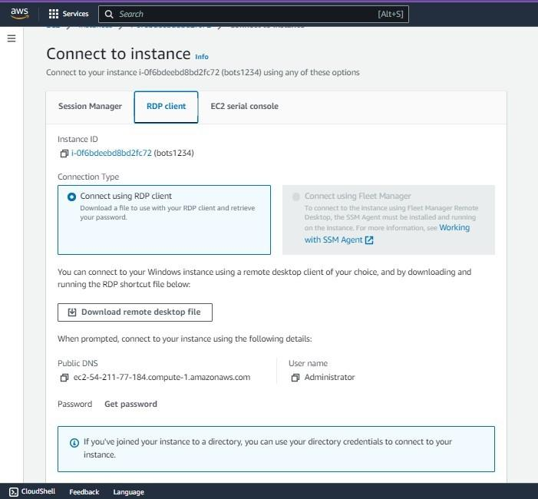

Step 9: Upload your private key to connect to your remote instance.

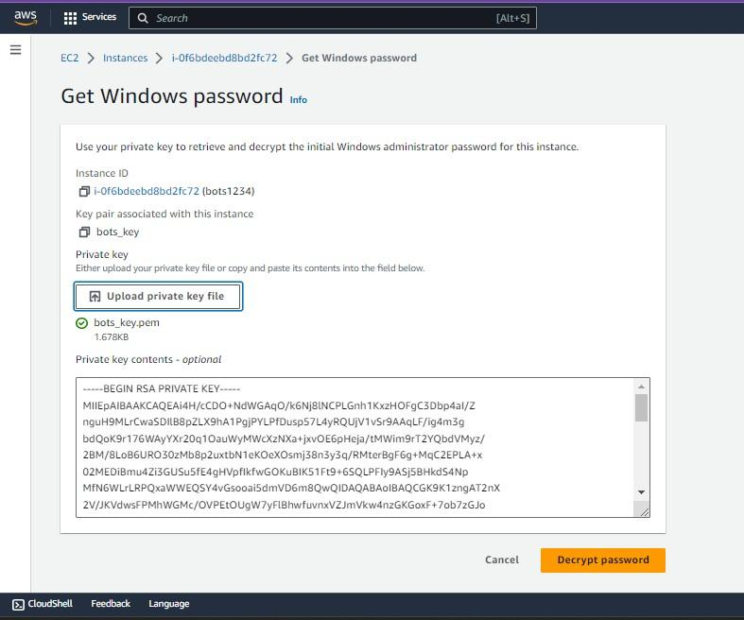

Step 10: Click on YES and Enter your private key to make secure connection.

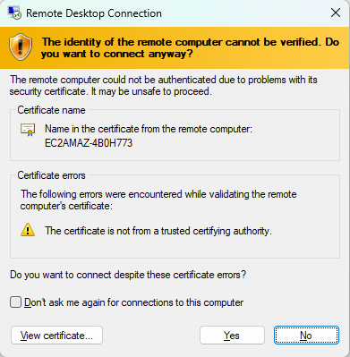

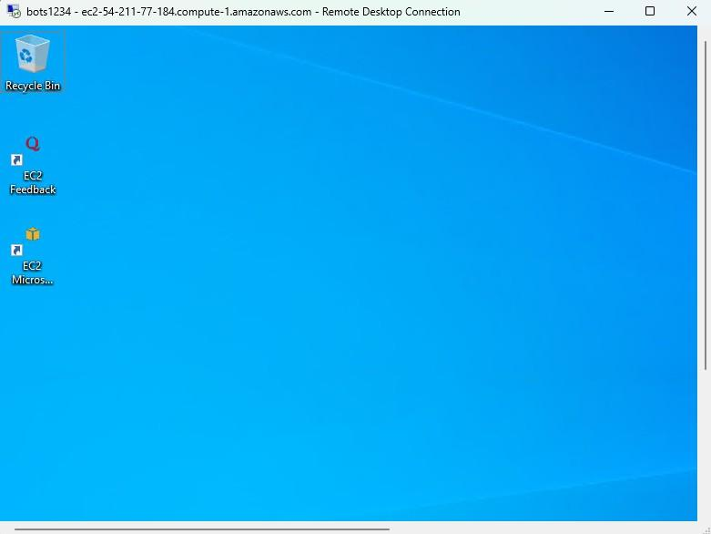

Step 11: Click on the Instances list find your remote instance and delete it.

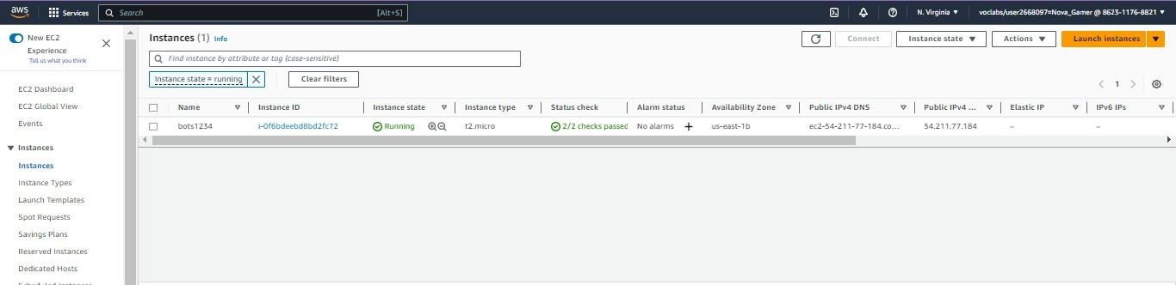

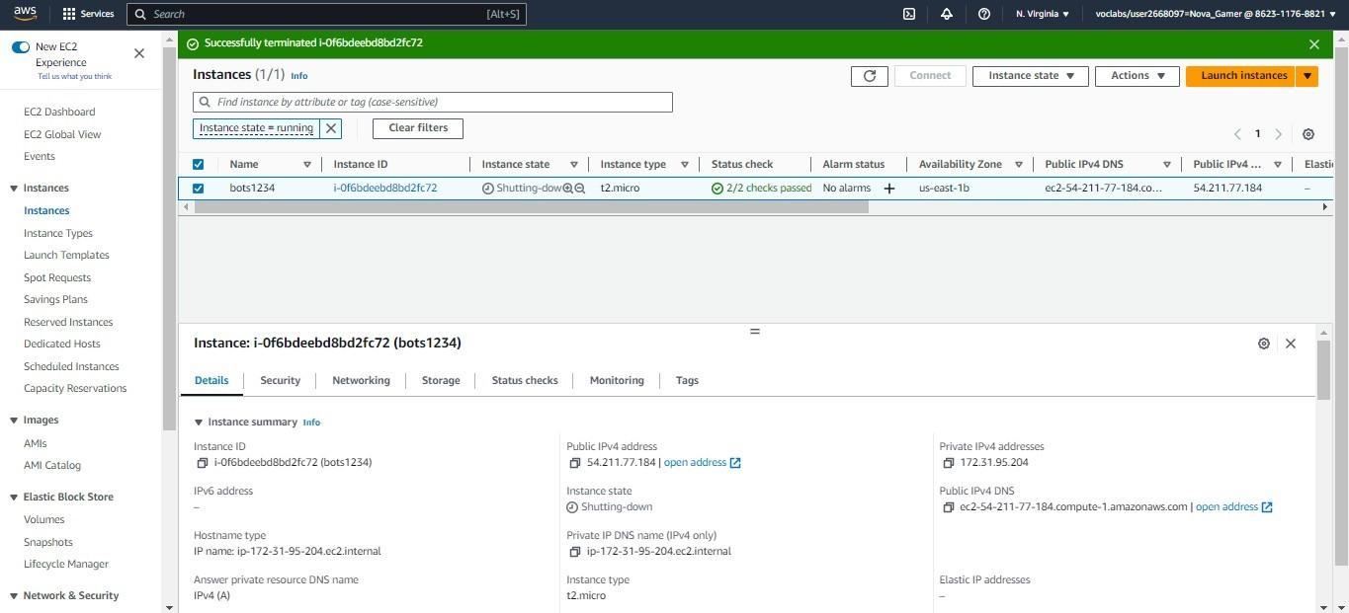

**Conclusion:-**